Security Official: Manage Access (Approve or Reject Requests)

# Introduction

This document will outline the steps a **Security Official** needs to take to **approve or reject** requests for access tothe Internet Quality Improvement Evaluation System (iQIES) from additional users, so they can view information or perform an action, such as submitting assessments on behalf of the organization.

Beginning February 2019, all Security Officials will approve requests by signing in to the HCQIS Access Roles and Profile (HARP) website, harp.qualitynet.org . This will allow Security Officials to manage all of their iQIES access request activities in one place.

#### **Helpful hint**

Consider adding a second (or third) Security Official to your organization to ensure someone is always available to approve requests.

There is no limit to the number of Security Officials your organization can have.

The main difference between the Security Official role and the other user roles is that Security Officials are responsible for approving (or rejecting) requests from additional users for their organization. If you are the only Security Official for your organization, you will be responsible for approving all requests.

There are three simple steps for approving role requests:

1. Sign in to the HCQIS Access Roles and Profile (HARP) website at <https://harp.qualitynet.org>
2. Navigate to the “Security Official” navigation item
3. Approve or reject the Pending Requests in your queue from “Role Requests” in the left sidebar

# Approval/Denial Role Request Workflow with Screenshots

## Step 1. Sign-in to HARP

Go to harp.qualitynet.org. Enter your **User ID** and **password** in the requested fields, agree to the **Terms and Conditions** and click **Login** (you will be prompted to provide a security code from your two-factor authentication.)

#### **New users**

Sign in with your newly created HARP credentials

#### **Don’t have an Account?**

Click **Sign Up** under the **Login** button.

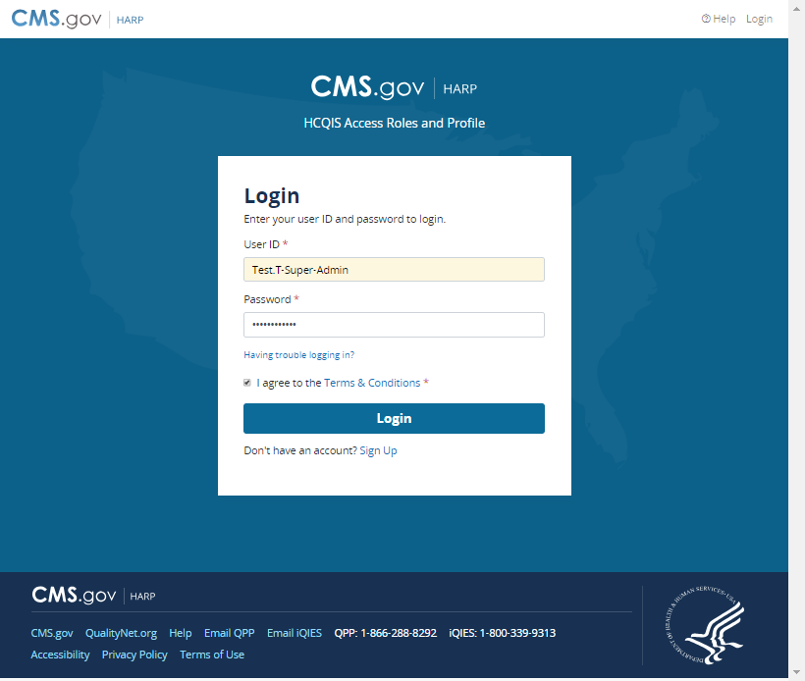

## Step 2. Navigate to Security Official

Once you are signed in to your HARP Account on harp.qualitynet.org, navigate to the **Security Official** navigation item.

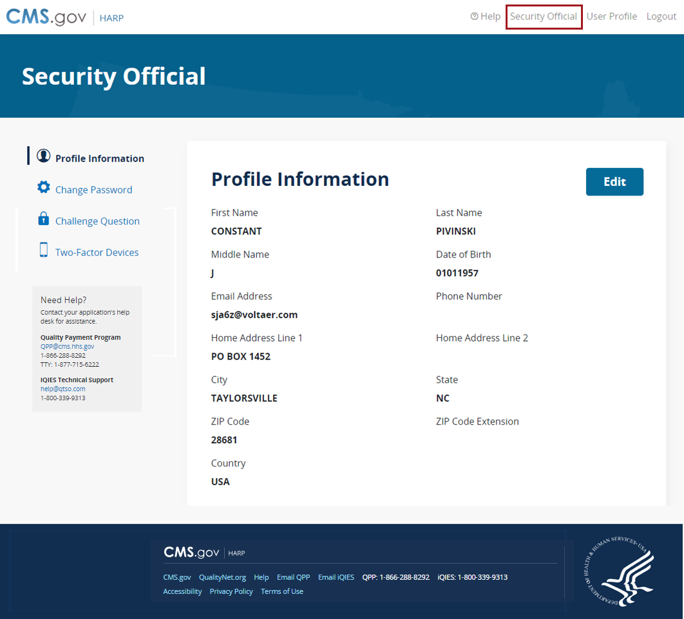

You will be redirected to the **User Lookup** page. All users within the selected organization are loaded by default.

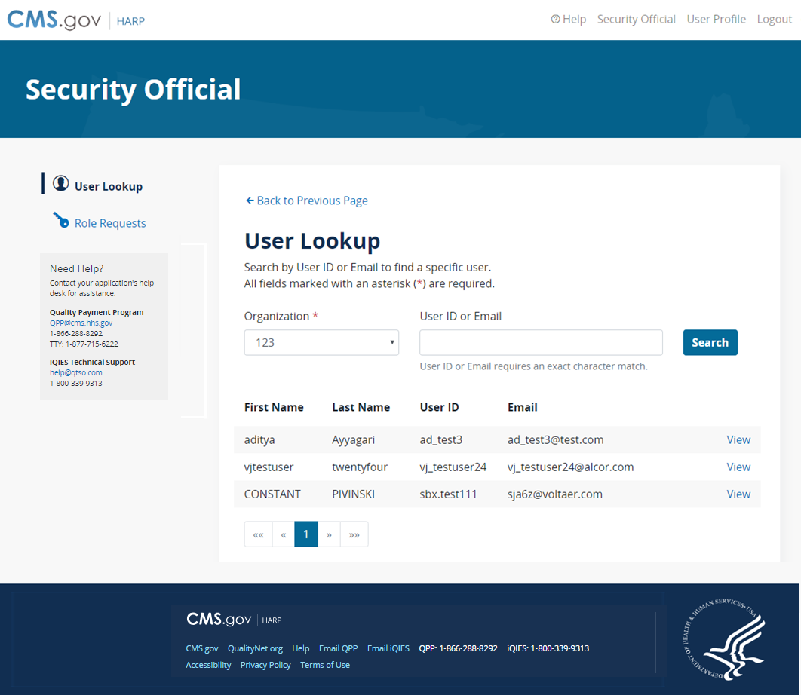

## Step 3. View Pending Role Requests

As a **Security Official**, you are responsible for **reviewing** outstanding role requests from other users and either **approving** or **rejecting** their requests.

You can view pending role requests directly by selecting the **Role Requests** sidebar item.

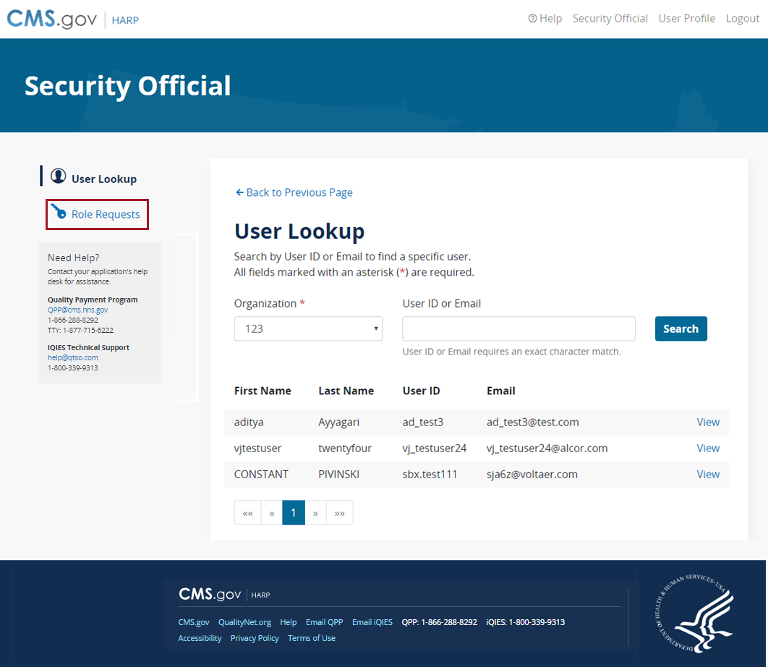

### Role Requests

The **Role Requests** page includes any **pending requests from other users** that you need to approve or reject as a current Security Official for an organization(s). If you are a Security Official for multiple providers, you will see pending requests for all of the providers you represent on this page.

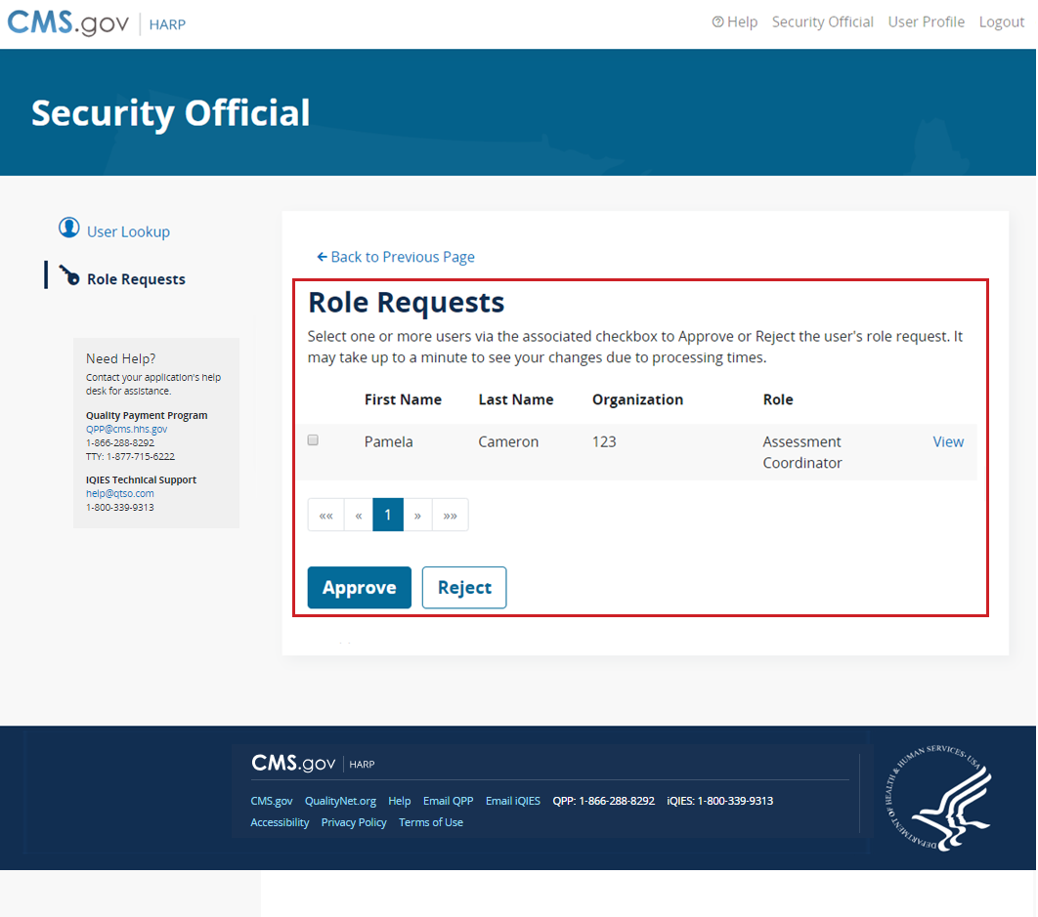

Select the checkbox next to the name and then select **Approve** or **Reject** as appropriate.

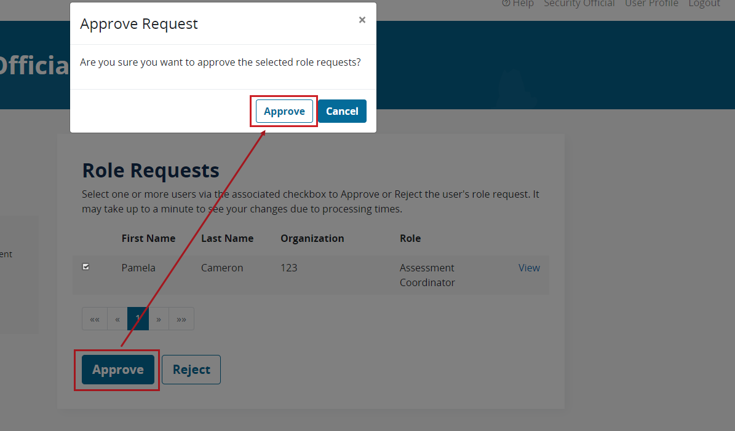

A **Rejection Reason** is required to Reject a request.

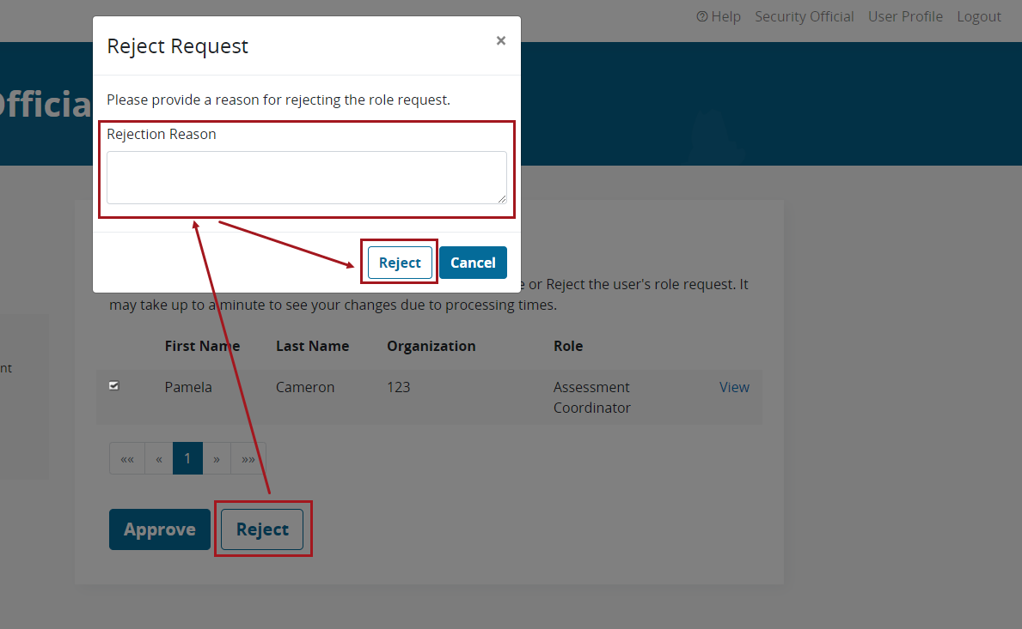

# Next Steps

* Monitor your email for pending request notifications so you can approve them quickly.
* Consider asking another person in your organization to request the Security Official role so there is always someone available to approve requests.

# FAQs

### **How are requesters notified of my decision to approve or reject their request?**

Requesters will receive an email telling them whether their request was approved or denied. This email will be sent to the email address they provided when registering for their HARP account.

### **I accidentally denied a request that I meant to approve. What do I do?**

Please contact the person whose request you denied and ask them to resubmit their request. If you don’t know how to contact the person, you will need to wait for them to resubmit the request on their own.

### **How many requests should I expect to approve?**

This depends on the size of your organization and how your organization will submit data. Generally, you should anticipate a higher volume of requests prior to and during the submission periods, and during the targeted review periods.

### **How do I remove a user who should no longer be authorized for my organization?**

On either the **User Lookup** or **Role Request** page, select **View** next to the user to access the **User Roles** page.

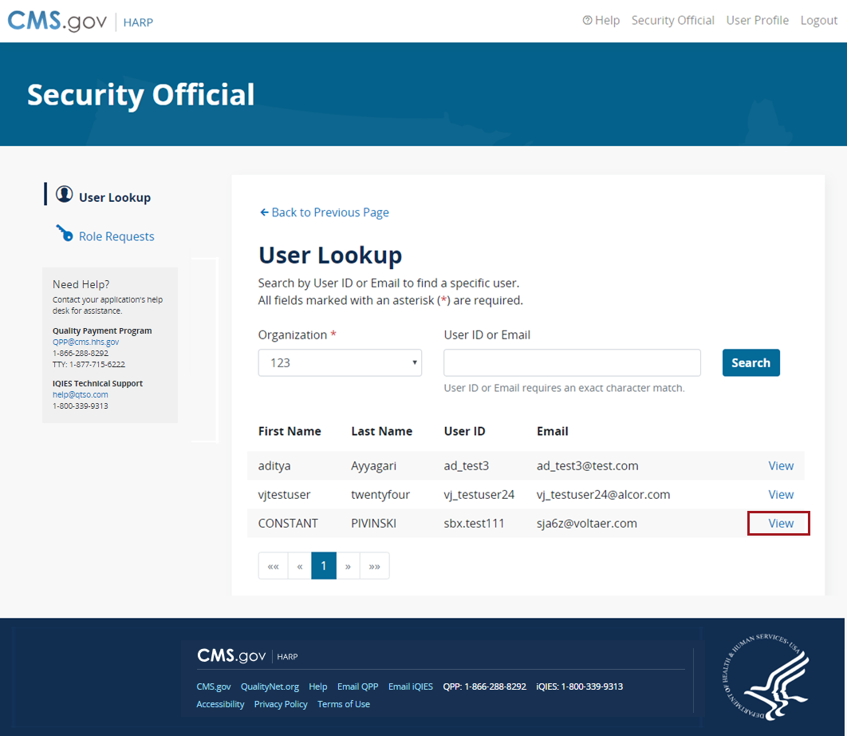

Select **Remove** adjacent to the role to remove from the user’s profile.

